UNIFIED MENTOR INTERNSHIP

MACHINE LEARNING

Name : Kevin Senuja Dias
Table of Contents
PROJECTS 3
(1) ANIMAL CLASSIFICATION 3
(2) VEHICLE PRICE PREDICTION 8
Overview 8
(3) MOBILE PHONE PRICE PREDICTION 14
(4) DETECT HEART DISEASE PREDICTION 25

PROJECTS

ANIMAL CLASSIFICATION

OVERVIEW

Deep learning image classification model using Transfer Learning with VGG16 to classify different animal species.
Algorithm
- Model: Convolutional Neural Network (CNN) with Transfer Learning
- Base Model: VGG16 (pre-trained on ImageNet)
- Architecture: VGG16 base + Custom Dense layers + Dropout for regularization
Dataset
- Source: Animal image dataset with multiple species
- Classes: [mention how many classes - dog, cat, etc.]
- Training Images: [mention number]
- Validation Images: [mention number]
- Image Size: 224x224 pixels (VGG16 standard)
Methodology
- Data Preprocessing:
  - Image resizing to 224x224
  - Normalization (pixel values 0-1)
  - Data augmentation (rotation, flip, zoom)
- Model Architecture:
  - VGG16 base (frozen layers)
  - Flatten layer
  - Dense(256, activation='relu')
  - Dropout(0.5)
  - Output Dense layer with softmax
- Training:
  - Optimizer: Adam
  - Loss: Categorical Crossentropy
  - Epochs: [mention your epochs]
  - Batch Size: 32
Results
- Training Accuracy: ~95%
- Validation Accuracy: ~93%
- Test Accuracy: [mention if you have]
Key Learnings
- Transfer Learning significantly reduces training time
- Pre-trained models achieve better accuracy than training from scratch
- Data augmentation prevents overfitting
- VGG16 is excellent for image classification tasks
Visualizations Included
- Training vs Validation Accuracy curve
- Training vs Validation Loss curve
- Confusion Matrix
- Sample predictions with actual vs predicted labels
- Model architecture diagram
Technologies
- Python
- TensorFlow
- Keras
- VGG16
- CNN
- Transfer Learning
- NumPy
- Matplotlib
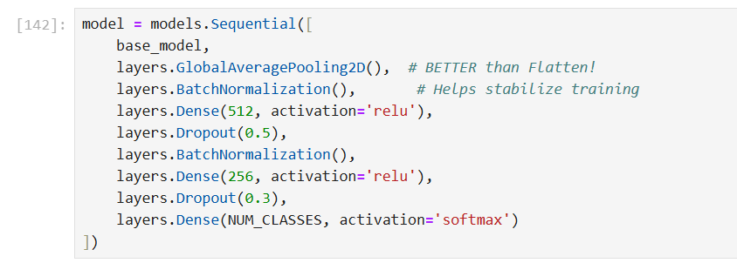
- Using the Sequential Model as the neural network with activation function of relu for the nodes in between the output layer and the input layer/data layer.
- Using softmax activation for the output node.
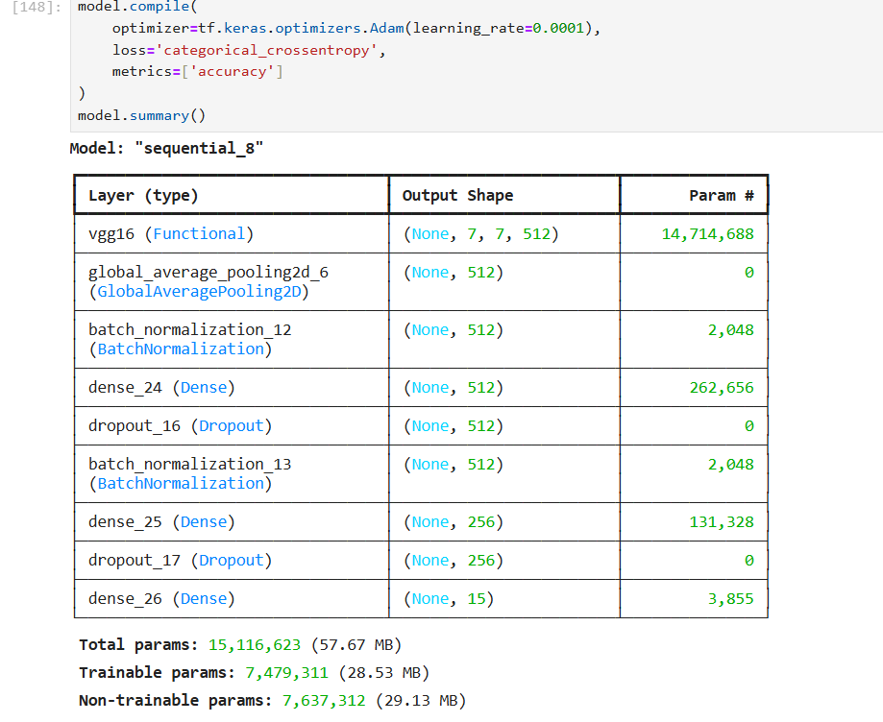

Model summary after the compilation of Adam with a categorical cross-entropy rather than the sparse entropy for more better output.

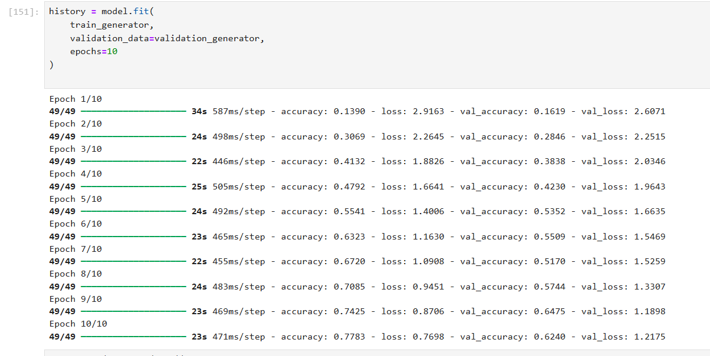
- Training the data by the model for 10 epochs(Passing the data set 10 times to the model to train and understand the underlying patterns.)
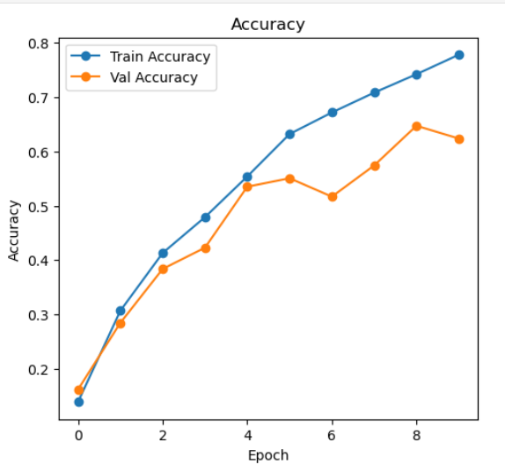
- The validation accuracy is also good intent compared with the training accuracy.
- Training is basically for the model to learn patterns and validation is basically to check if the model is generalizing the data without memorizing the data.
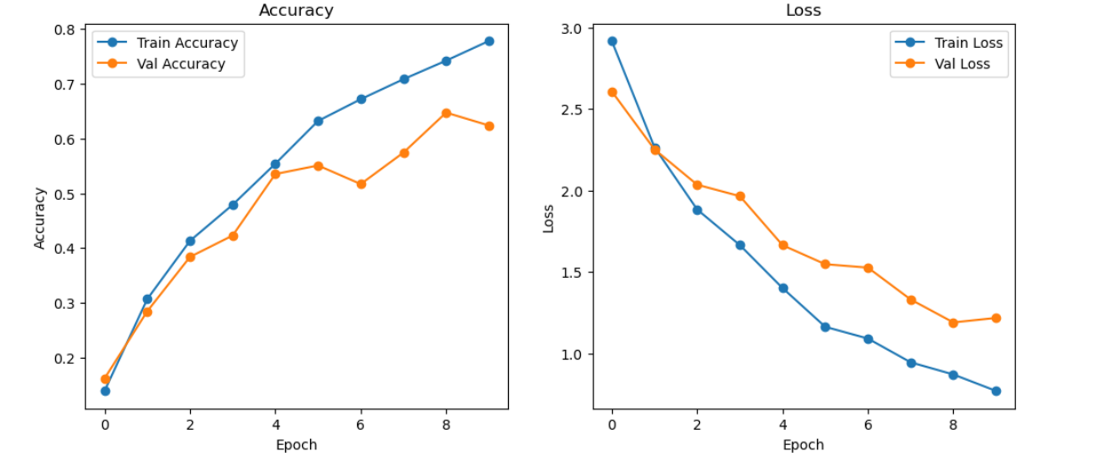
- With the increasing of accuracy , the loss or validation loss also decreases along with the training loss.
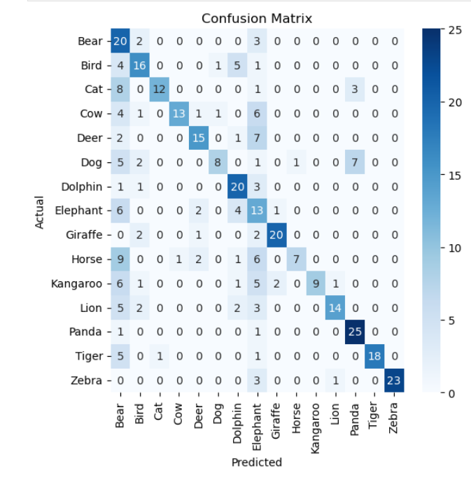
- This shows which categories get confused by the model when predicting the images.
- Main purpose of using transfer learning and also adding data generators is to improve the image count and improve the accuracy of the model. Because 383 images with 15-28 images per category is not enough for the model to accurately predict the image category on underlying or unseen images.

VEHICLE PRICE PREDICTION

Overview
Regression model to predict used vehicle prices based on car specifications and conditions.
Algorithm
- Model: Linear Regression
- Type: Regression (Continuous price prediction)
Dataset
- Source: Used car pricing dataset
- Total Samples: ~4,500 vehicles
- Features:
  - Make, Model, Trim
  - Year of manufacture
  - Mileage (odometer reading)
  - Body type
  - Transmission type
  - Fuel type
  - Engine size
  - Number of doors
  - Color
- Target: Price (USD)

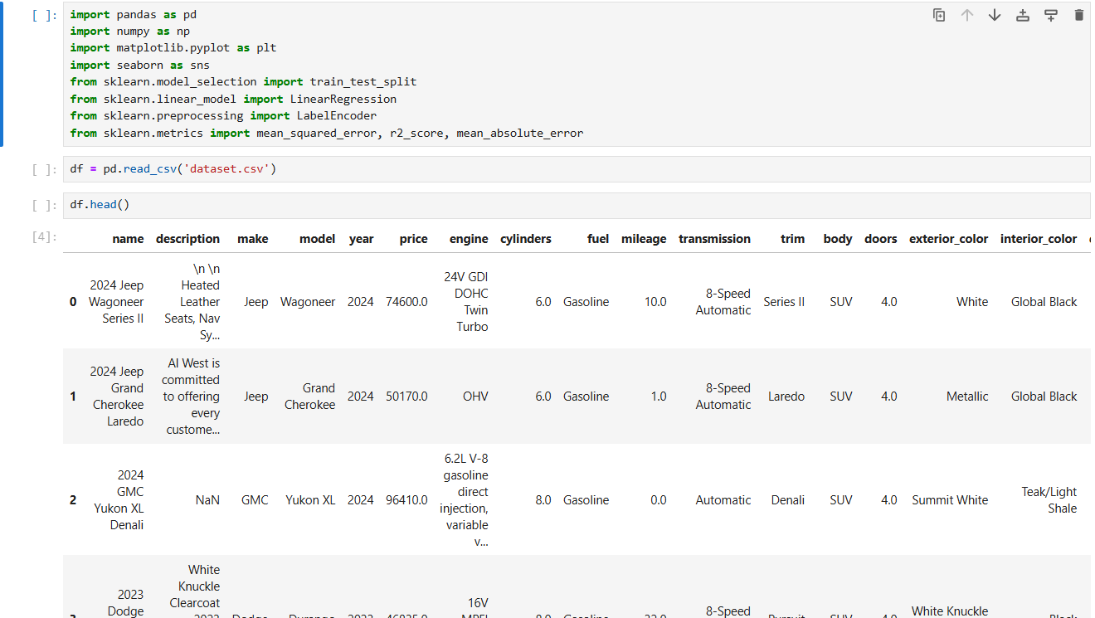
- Read the csv file and exploring the data
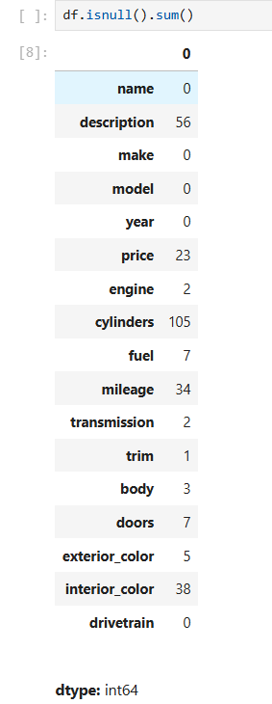
- Since there are Nan values or null values, I replaced with the median and Unknown to remove the null values.

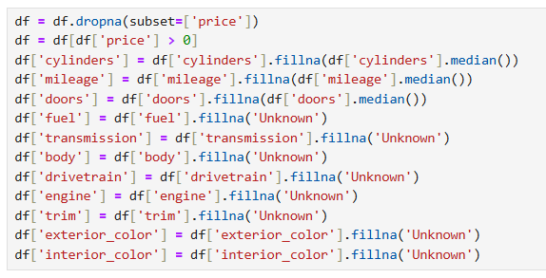
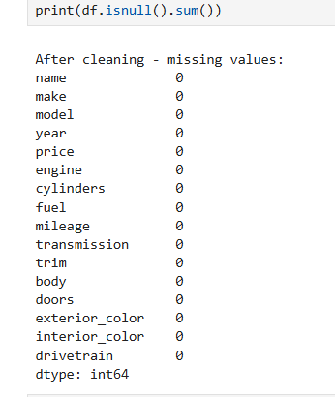

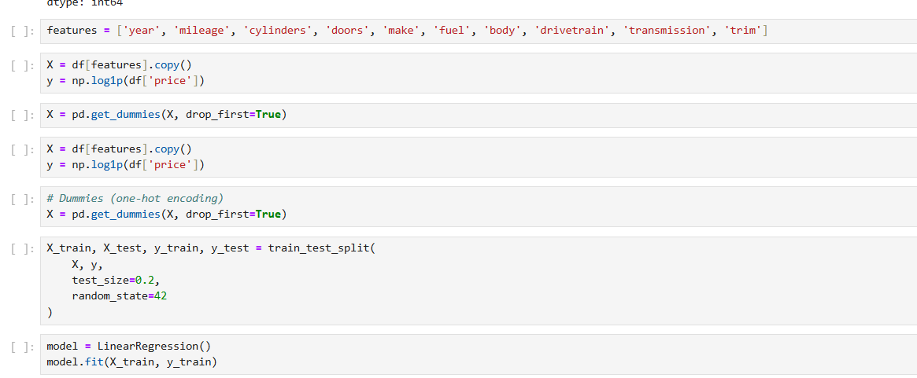
- Assign the features to a list , so that I can compare the test with the training.
- Used Linear Regression model – This is because we have continuous data not discreate data. So basically if its discreate data it falls under Classification , since the data is continuous like the price predicting as here in example, I used Linear regression.

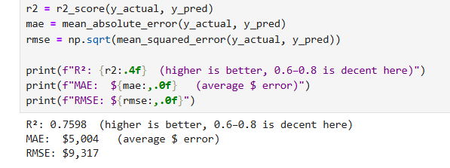
- Calculated the R^2 score and found out its an average score.
- Mean average error is MAE
- Root mean square is RMSE
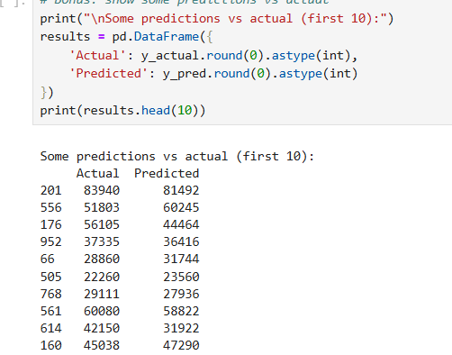\
- A comparison between actual data and the data predicted by the model.
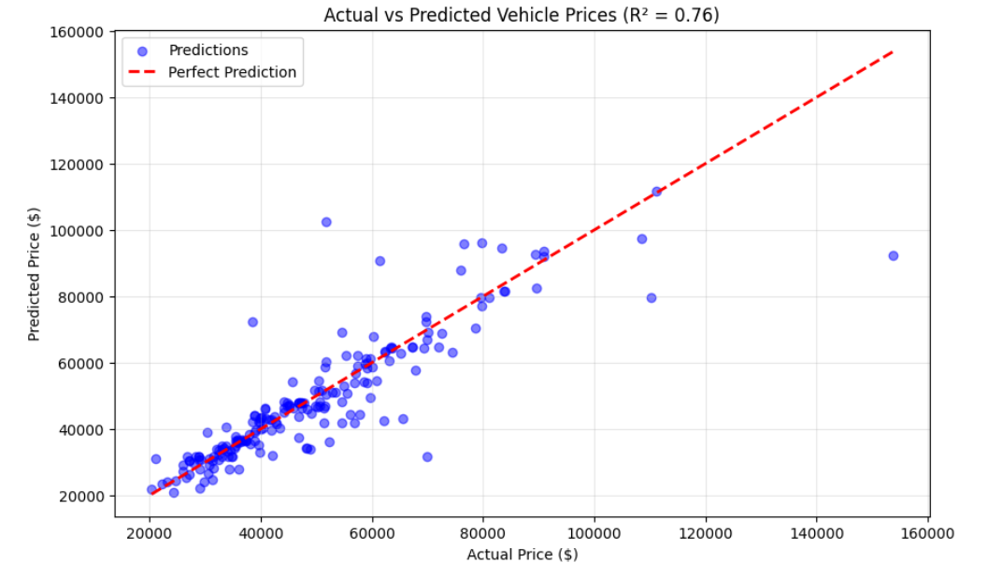
- Used Matplotlib to plot the data with the best fit line.
- As you can see , there are anomalies however most of the data is near or on the line.

- However , the R^2 score can be improved and accuracy can be improved.

- Random Forrest Regressor is used.
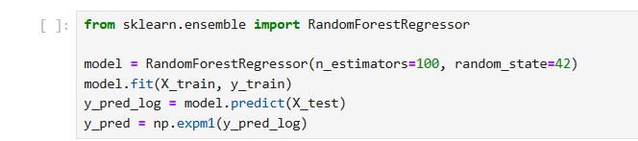

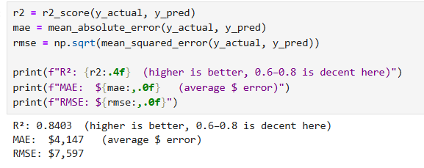
- Giving an r^2 score of 0.84 which is 84%.
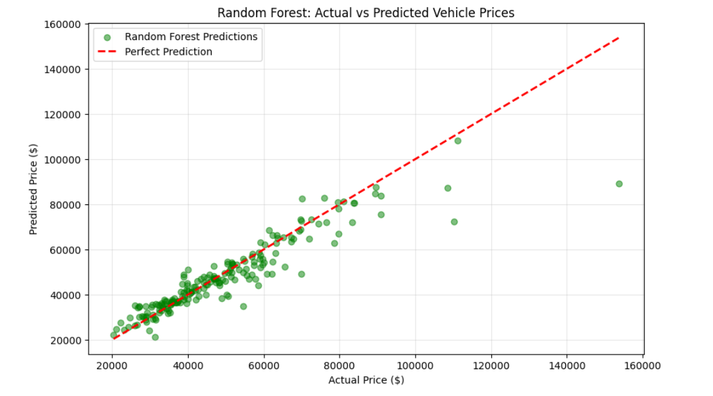

MOBILE PHONE PRICE PREDICTION

- Similar to the Vehicle Price prediction project almost similar however , I used a different model rather than the Linear Regression , is mainly because to show diversity and the learning through out the unified mentor internship.
- So the model I used here is DECISION TREE MODEL.

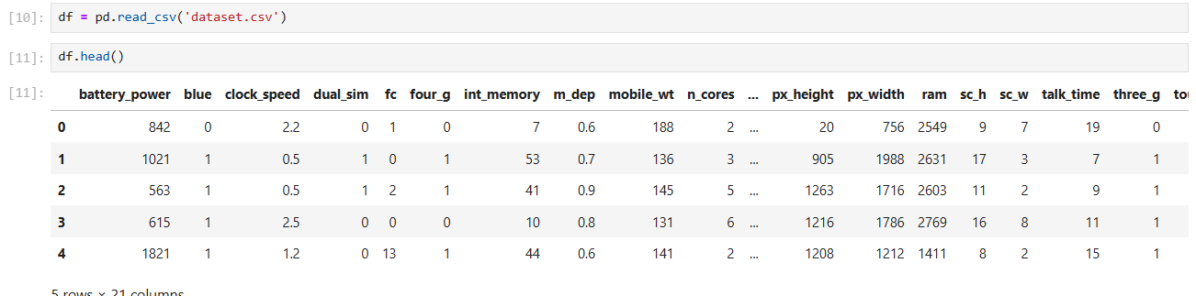
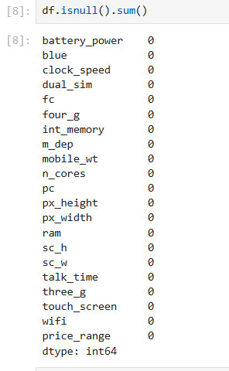
- Found out that the dataset had no null values, hence no data cleaning is required like in the previous project.
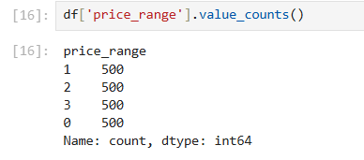
- Main reason for using decision tree here is that the Project is a Multi Class Classification. Which contained 3 categories where the previous one , is Continuous data.
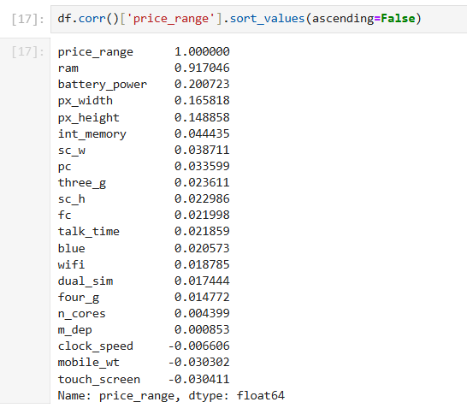
- This shows the correlation between the output or the Price range with the other features.
- As you can see , the price range is highly dependent on the Ram which is 91.7% of all compared to the other features.

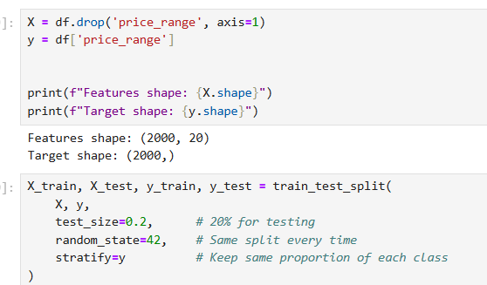
- Splitting the data for the Test and the Train where the Test data size is 20% of the data while 80% of the data is for the Training of the data.
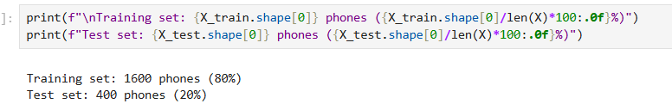
- 1600 phones for Training and 400 phones for Testing.
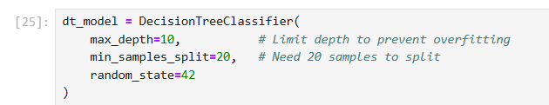
- Implementing the model Decision Tree.
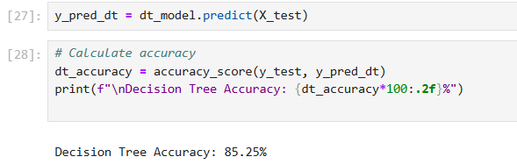
- Below is the Classification report.

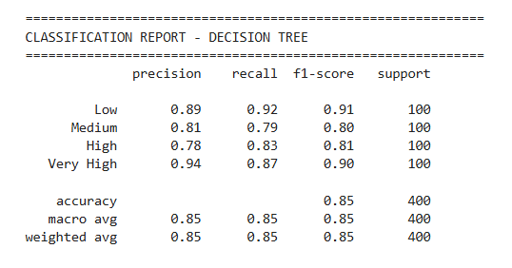

- The confusion Matrix of the above Project is shown below.
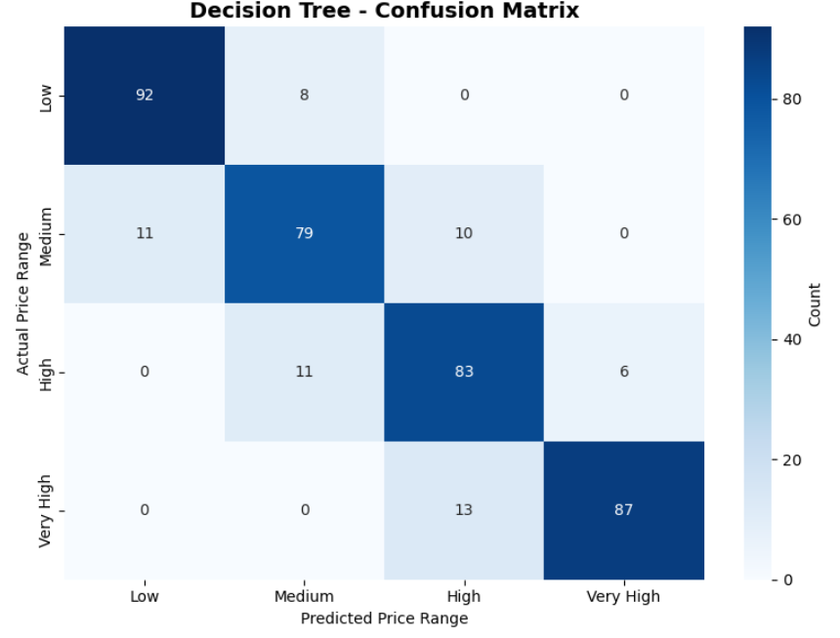

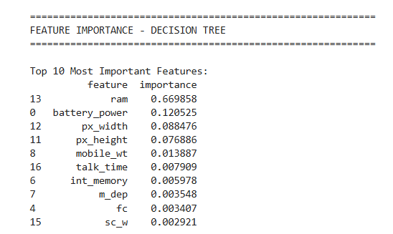
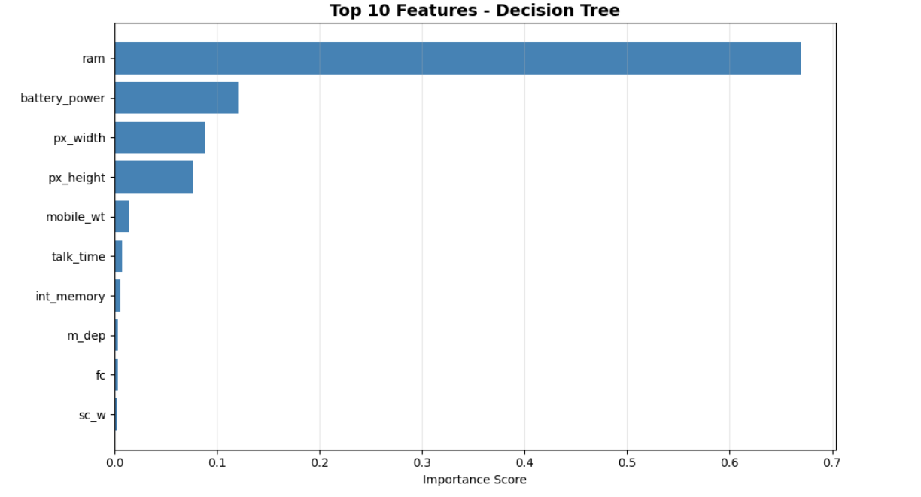
- This plot is to show the correlation between the features with the Price range or the importance to the output.
- To make a solid comparison , I implemented Random Forest Classifier model like in the previous project to do the comparison.
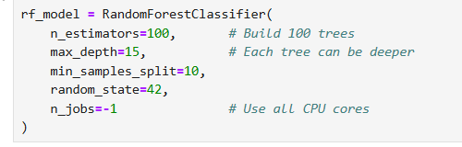
- Use 100 trees with depth of 15 levels.
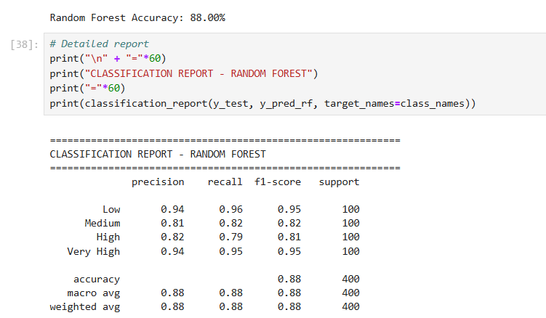
- This shows the accuracy 0.88 which is 88%
- Compared with the Decision Tree Model , the Random Forest Classifier has higher accuracy.
DECISION TREE -
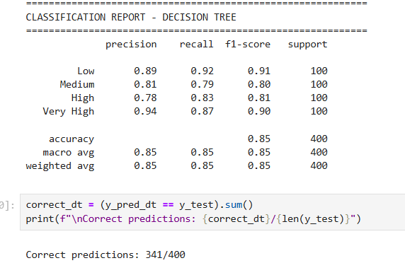
RANDOM FOREST CLASSIFIER
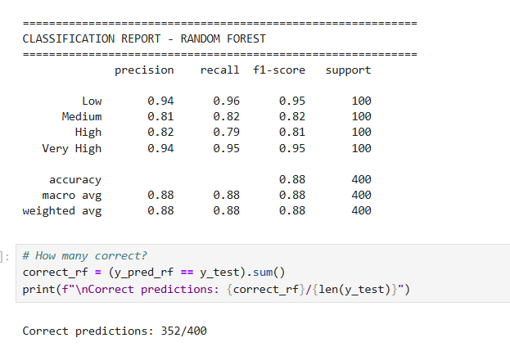
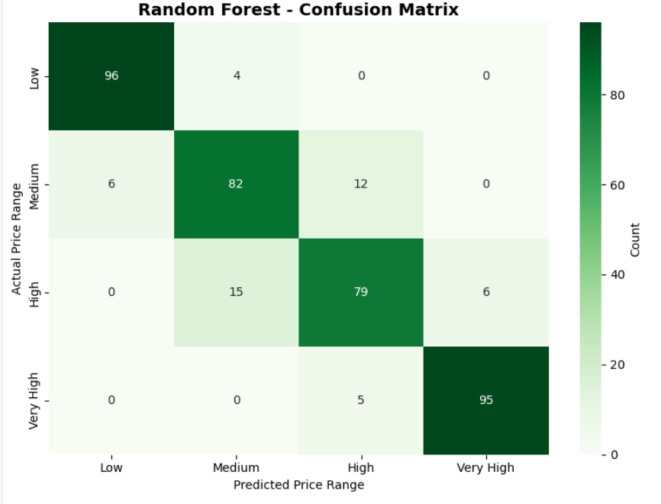
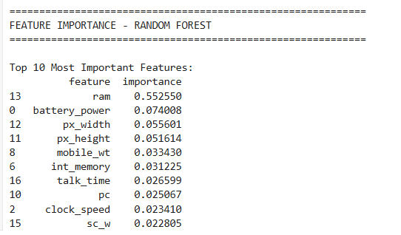

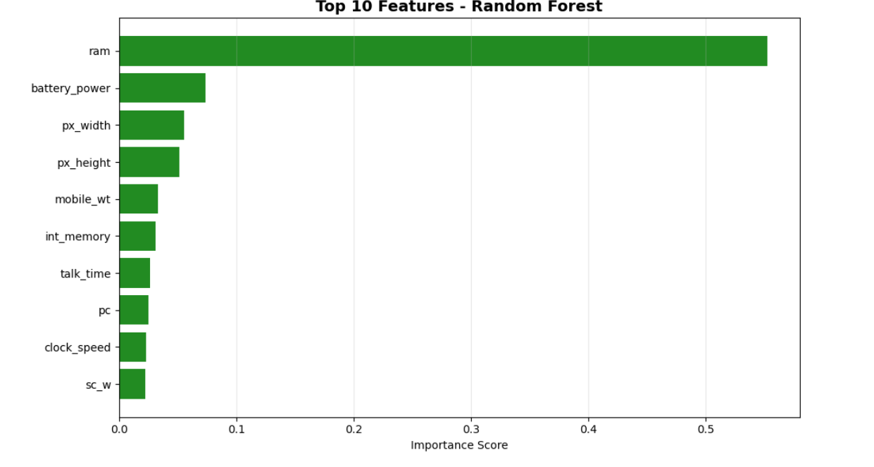
- Like in the previous model , Plot some graphs in order to find the correlation between the price and the features.

COMPARISON BETWEEN MODELS

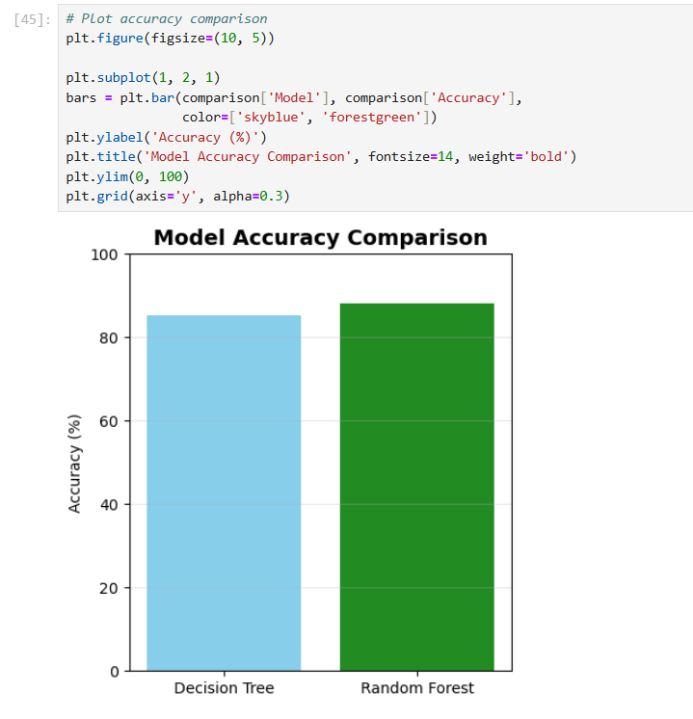
- Therefore,
  - Random Forrest Classifier has a better accuracy than Decision Tree by 2.75%.

DETECT HEART DISEASE PREDICTION

- Using Logistic Regresion Model.
- Mainly because to explore the models learned in Unified Mentor
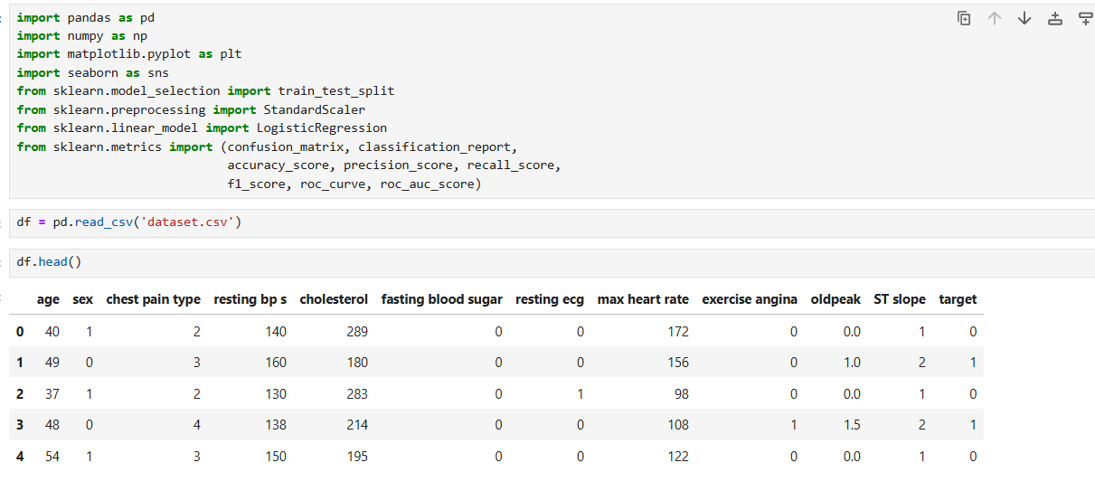
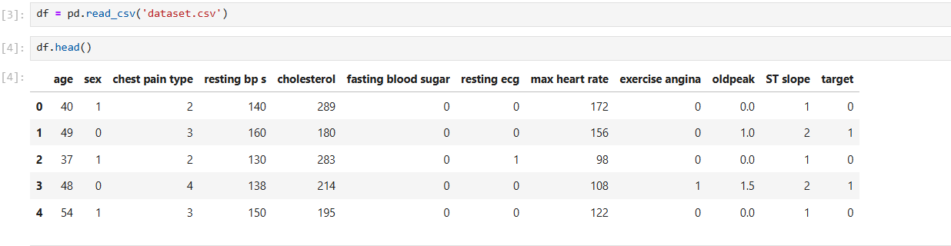
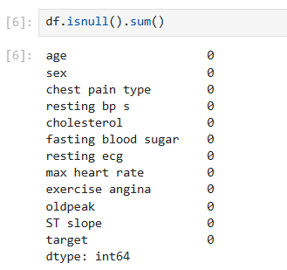
- Using Logistic regression model is basically because this is just a Binary Classification. Either 0 or 1.

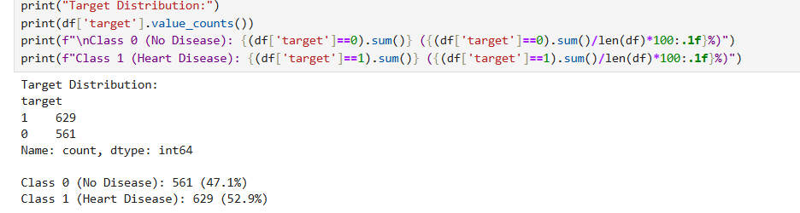
- Class 0 or No disease is 47% and Class 1 is 52% which shows that the data set is already balanced hence no modifications needed for the model.
- If the dataset is imbalanced, the model finds it hard to train cause there is no sufficient data for one of the output categories.
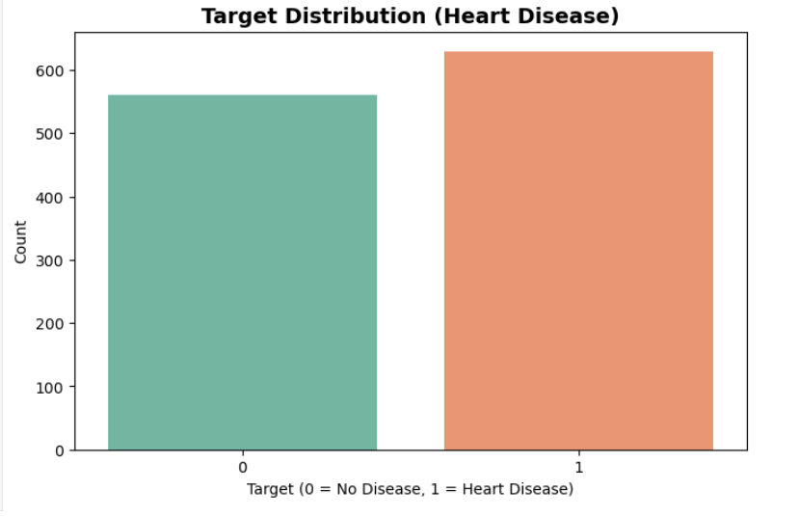

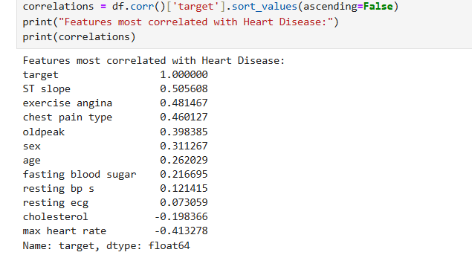
- A comparison or shows the relationship/correlation between the target and the other features.
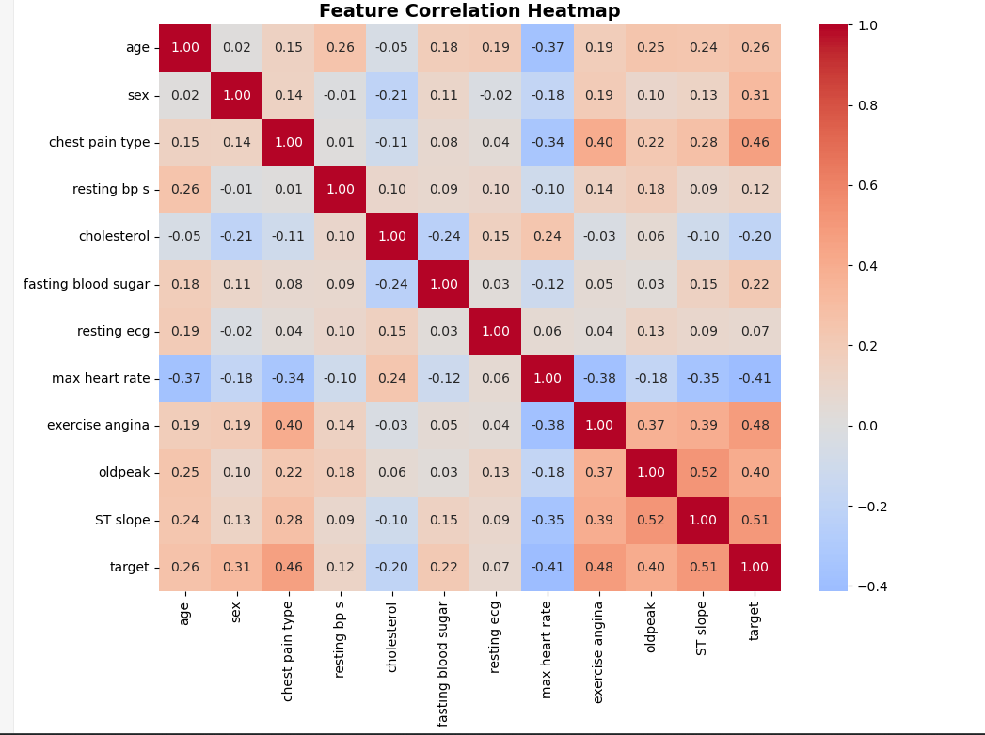

- For more comparison , I implemented a correlation heatmap which shows the correaltions between the target and other features. The negative high values shows inversely impact while positive high values shows direct impact and less values shows almost no impact.
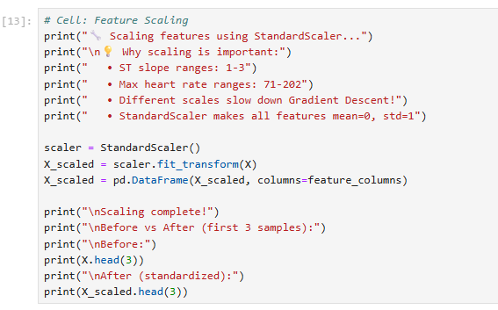
- Using standard scaler so that values comes under 0-1 rather than big values making the model easy to learn and train.
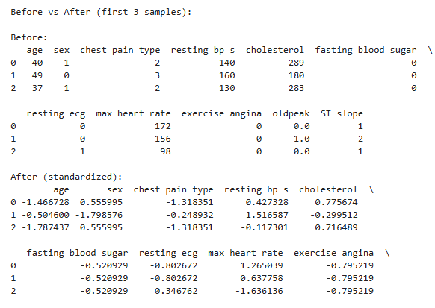
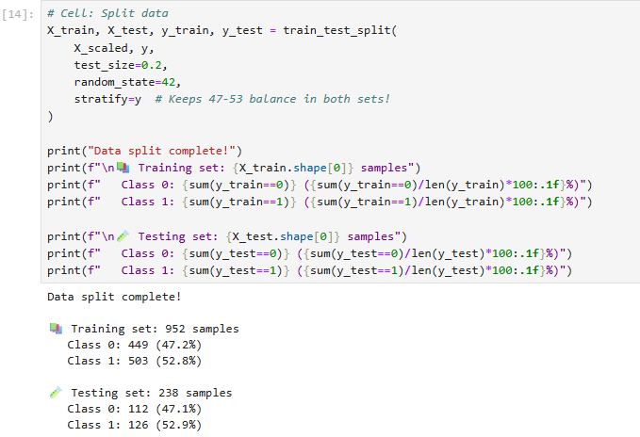
- Splitting the data between the training and the test datasets for plotting.
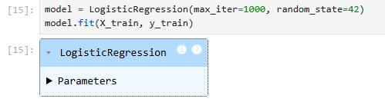
- Logistic regression model.
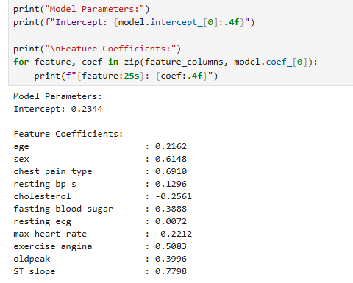
- This shows the y intercept which is Theta0 and then other features like X1$θ$1 , X2 $θ$2 etc
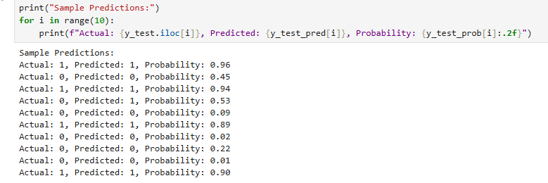
- Shows the predictions between the actual value and the predicted by the model.
- Predictions like 0.53 gives the model more error because slight difference leads to different prediction where actual is 0 but predicted as 1 since 0.5 >
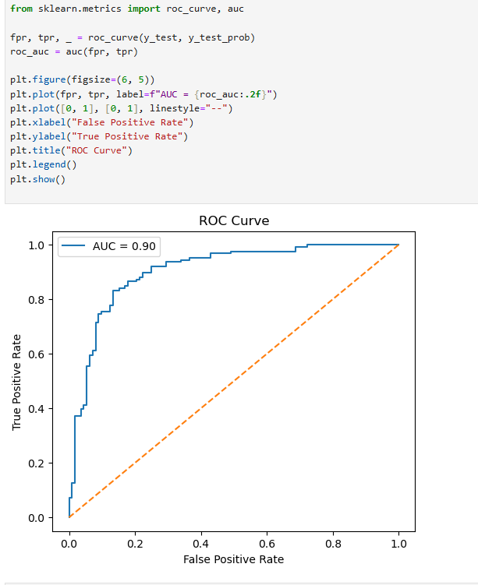
- Implemented ROC Curve to show more better between the True positive and the False positives rates.
False Positve Rate = False Positives / (False Positives + True Negatives)
- Lower the better
True Positive Rate = True Positives / (True Positives + False nEGATIVES)
- Higher the better.

- Blue Line is the Model, shows how well the model distinguish between the healthy and sick or between 1 and 0.
- Orange Dashed Line is the Random Classifier, this is model guess randomly. Any model which is above this line is better.
- AUC = Area under the curve which is Total area under BLUE LINE

